UNIT 4
Lesson 2 – WHAT TO DO?
- 1 a) Look at the pictures. Read the expressions.
Tick  your favourite activities.
Pogledaj slike. Pročitaj izraze koji ih opisuju.
Kvačicom označi svoj omiljene aktivnosti.
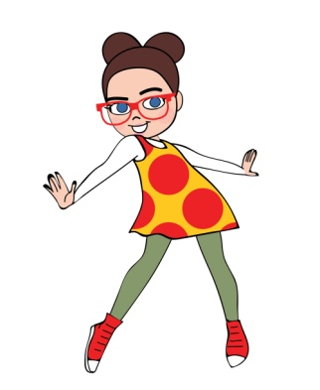
to make a cake to do homework to go dancing
(praviti tortu) (raditi zadaću) (plesati)
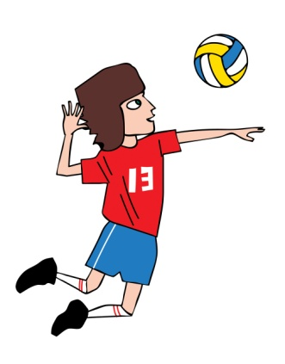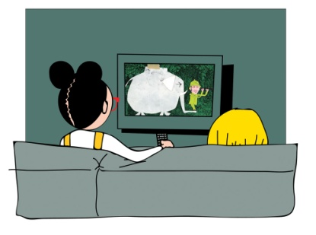
to play volleyball to watch a TV series
(igrati odbojku) (gledati TV serije)
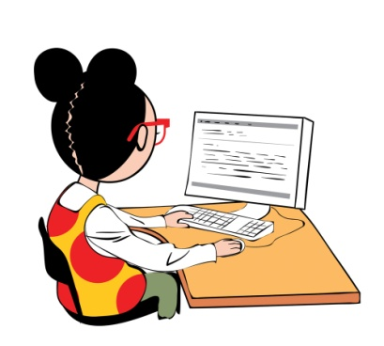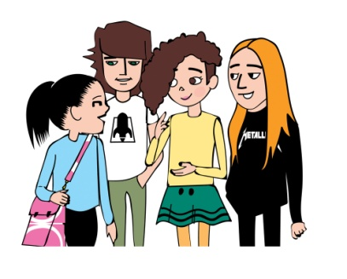
to browse the Internet to talk to a friend
(surfati po internetu) (pričati s prijateljem/prijateljicom)

b) Choose three activities that you like the most.
Finish the sentences.
Izaberi tri aktivnosti koje naviše voliš raditi.
Dovrši rečenice.

I like _________________________________________ .
(Volim…)

I like _________________________________________ .

I like_________________________________________ .

c) Match the pictures with the expressions.
Upari sličice s izrazima.



to talk to a friend
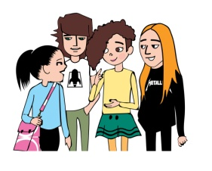
to watch a TV series
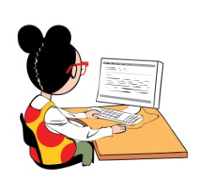
to browse the Internet
to play volleyball
to do homework
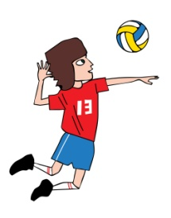
to go dancing
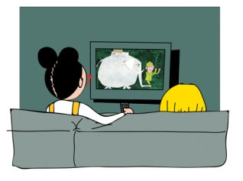
to make a cake

- 2 a) Listen to Tia talk about her free time.
Talk to your teacher about what you remembered.
Poslušaj Tiju kako priča o svom slobodnom vremenu.
Razgovaraj s učiteljem / učiteljicom o onome što si zapamtio.

b) Listen to Tia once again.
What days does Tia mention?
Poslušaj snimku Tije još jednom.
Koje dane u tjednu spominje?

What activities does she mention?
Circle the activities and days she mentions.
Koje aktivnosti spominje?
Zaokruži dane i aktivnosti koje spominje.
make a cake Wednesday Monday
swim dance run Thursday
skiing stay at home Tuesday
watch a film Sunday do homework
spend time with friends play volleyball
browse the Internet go to the cinema

- 3 a) What do you usually do on different days?
Što obično radiš svaki dan u tjednu?
Cut  the pictures with the expressions.
Glue them under the correct day of the week.
Izreži sličice s izrazima:
Nalijepi ih ispod određenog dana u tjednu.

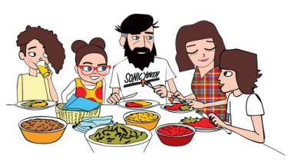  spend time with my family  provodim vrijeme s obitelji | 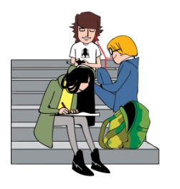  spend time with my friends  provodim vrijeme s prijateljima
  do my homework  radim domaću zadaću | 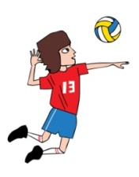  play (volleyball)  igram (odbojku)
  play computer games  igram video igre | 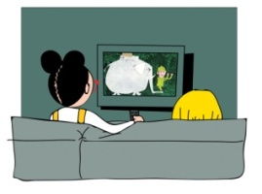  watch my favourite TV show  gledam svoju omiljenu emisiju
(dodaj svoju ideju) | (dodaj svoju ideju, nađi sliku ili nacrtaj, napiši uz pomoć učitelja)

Monday | Tuesday
Wednesday | Thursday
Friday | Saturday
Sunday

b) Finish the sentences 1-7.
Use the expressions from task 2 b).
Dovrši započete rečenice izrazima iz 2 b) zadatka.

1 On Monday, I _______________________________ .
2 On Tuesday, I _______________________________ .
3 On Wednesday, I ____________________________ .
4 On Thursday, I ______________________________ .
5 On Friday, I _________________________________ .
6 On Saturday, I _______________________________ .
7 On Sunday, I ________________________________ .

c) Answer the questions.
1 What is your favourite day of the week?
Koji je tvoj najdraži dan u tjednu?

My favourite day of the week is _______________ .
Moj omiljeni dan u tjednu je…
2 What do you usually on that day?
Što (obično) radiš toga dana u tjednu?

I usually __________________________________ .
Toga dana obično…
3 What is your least favourite day of the week?
Koji ti je dan u tjednu najmanje drag?

My least favourite day of the week is _____________ .
Najlošiji dan u tjednu za mene je…
4 What do you usually do on that day?
Što (obično) radiš toga dana u tjednu?
I usually __________________________________ .
Toga dana obično…

d) Project. Make your weekly planner.
Tick the right day for each activity that you do.
Some activities happen more than once in a week.

Projekt. Napravi svoj tjedni plan.
Kvačicom označi točan dan uz aktivnost. Budi pažljiv / pažljiva,
neke od aktivnosti obavljaš više od jedanput u tjednu.

 | Monday | Tuesday | Wednesday | Thursday | Friday
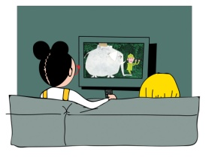
watch a film
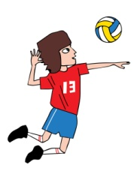
play sports
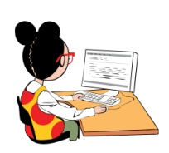
play video games

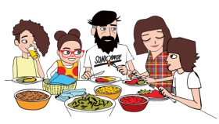stay at home

MY WEEKLY PLANNER

 | Monday | Tuesday | Wednesday | Thursday | Friday

go to the cinema
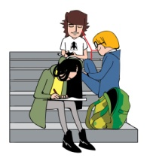 spend time with friends

do homework
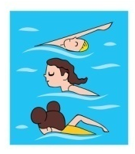
swim

dance
(dodaj svoju aktivnost)
(dodaj svoju aktivnost)
(dodaj svoju aktivnost)

e) Finish the sentences. Find help in task 2 b).
Dovrši Tijine rečenice. Potraži pomoć u zadatku 2 b).

Tia says:
Tia kaže:

1 On Monday, I usually make cake .______________
2 On Tuesday, I ______________________________ .
3 On Wednesday, I ___________________________ .
4 On Thursday, I _____________________________ .
5 On Friday, I _______________________________ .
6 Everyday, I ________________________________ .

